Demonstration School of Suan Sunandha Rajabhat University
SOCIAL STUDIES, RELIGION AND CULTURE Date : 30/07/2019
Nickname: ..............................…………………………………....... Grade:4 /......... No: ………...
…………………………………………………………………………………………………………………………………
Did you know?
What 10 moral virtues that all the Kings use to govern our country?
1. ………………………………………………………………………………………………………………………………………………………………………………………………………………………………………………………………………………………………………………………..
2. ………………………………………………………………………………………………………………………………………………………………………………………………………………………………………………………………………………………………………………………….
3. ………………………………………………………………………………………………………………………………………………………………………………………………………………………………………………………………………………………………………………………….
4. …………………………………………………………………………………………………………………………………………………………………………………………………………………………………………………………………………………………………………………………
5. …………………………………………………………………………………………………………………………………………………………………………………………………………………………………………………………………………………………………………………………
6. …………………………………………………………………………………………………………………………………………………………………………………………………………………………………………………………………………………………………………………………
7. …………………………………………………………………………………………………………………………………………………………………………………………………………………………………………………………………………………………………………………………
8. …………………………………………………………………………………………………………………………………………………………………………………………………………………………………………………………………………………………………………………………
9. …………………………………………………………………………………………………………………………………………………………………………………………………………………………………………………………………………………………………………………………10. ………………………………………………………………………………………………………………………………………………………………………………………………………………………………………………………………………………………………………………………..
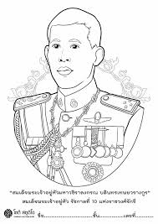

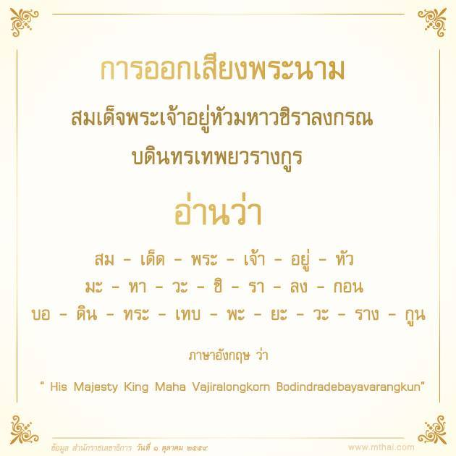
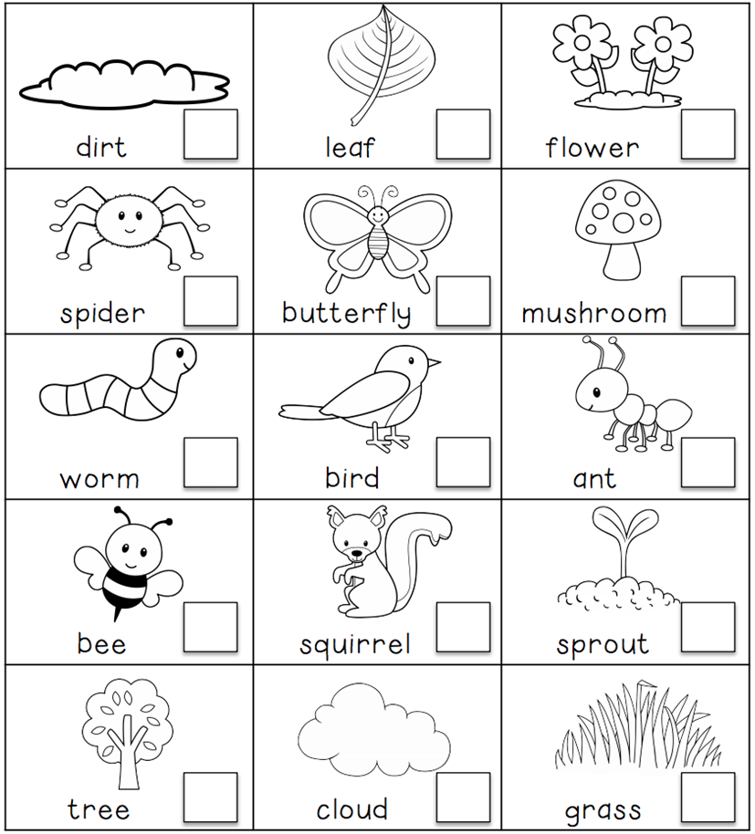
Subject teacher…………………………………..... Reviewer………………………………………

