**worksheet**



**Demonstration School of Suan Sunandha Rajabhat University**

**SOCIAL STUDIES, RELIGION AND CULTURE Date : 30/07/2019**

**Nickname: ..............................………………………………….......** **Grade:4 /......... No: ………...**

**…………………………………………………………………………………………………………………………………**

**Did you know?**

**What 10 moral virtues that all the Kings use to govern our country?**

1. ………………………………………………………………………………………………………………………………………………………………………………………………………………………………………………………………………………………………………………………..

2. ………………………………………………………………………………………………………………………………………………………………………………………………………………………………………………………………………………………………………………………….

3. ………………………………………………………………………………………………………………………………………………………………………………………………………………………………………………………………………………………………………………………….

4. …………………………………………………………………………………………………………………………………………………………………………………………………………………………………………………………………………………………………………………………

5. …………………………………………………………………………………………………………………………………………………………………………………………………………………………………………………………………………………………………………………………

6. …………………………………………………………………………………………………………………………………………………………………………………………………………………………………………………………………………………………………………………………

7. …………………………………………………………………………………………………………………………………………………………………………………………………………………………………………………………………………………………………………………………

8. …………………………………………………………………………………………………………………………………………………………………………………………………………………………………………………………………………………………………………………………

9. …………………………………………………………………………………………………………………………………………………………………………………………………………………………………………………………………………………………………………………………10. ………………………………………………………………………………………………………………………………………………………………………………………………………………………………………………………………………………………………………………………..

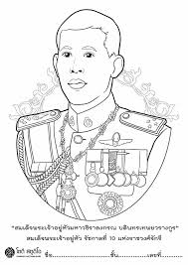

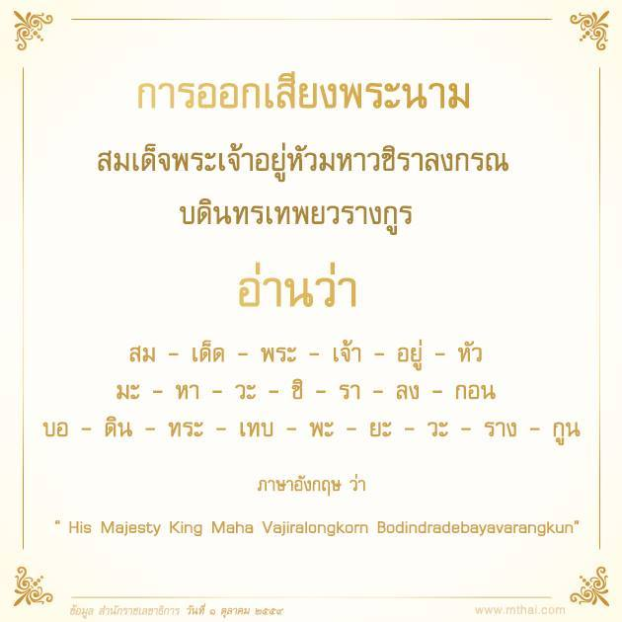

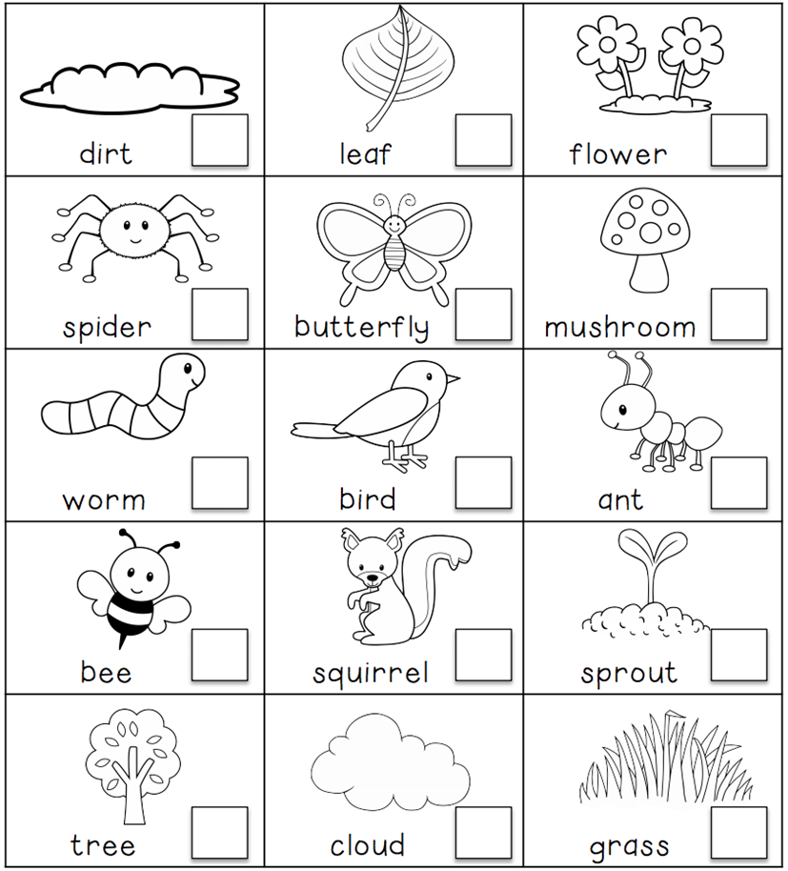

Subject teacher…………………………………..... Reviewer………………………………………