Demonstration School of Suan Sunandha Rajabhat University
SOCIAL STUDIES, RELIGION AND CULTURE Date : 15/01/2019
Name: ..............................…………………………………....... Grade:2 /......... No: ………...
Order the Planets
Identify the planets and write their names.
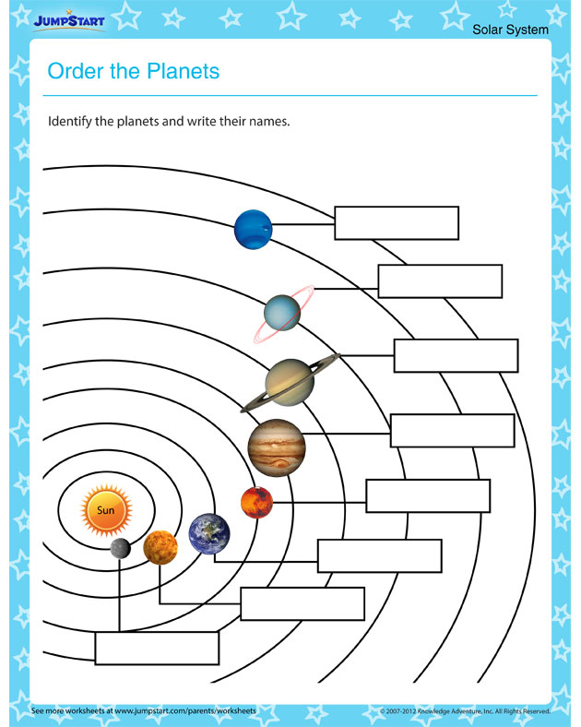

Subject teacher…………………………………… Reviewer………………………….................

