Worksheet
How can I help " MY family " at home?
Example : of writing a student's drawing the sentence.
i.e. I can help wash the dishes.
I can help clean the kitchen.
I can help wash the car.
I can help make the bed.
I can help take out the trash.
I can help To cook for dinner etc.

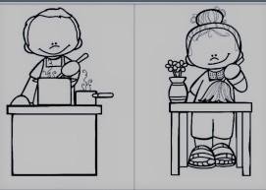
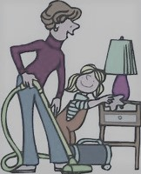

How can I help " MY family " at home?

............................................................................................................................................................
...............................................................................

