Demonstration School of SuanSunandhaRajabhat University
Science, Teacher : Miss Nungrutai Camhongsa
Name :……………………………..……..………………….Class…..…..…No……….

. 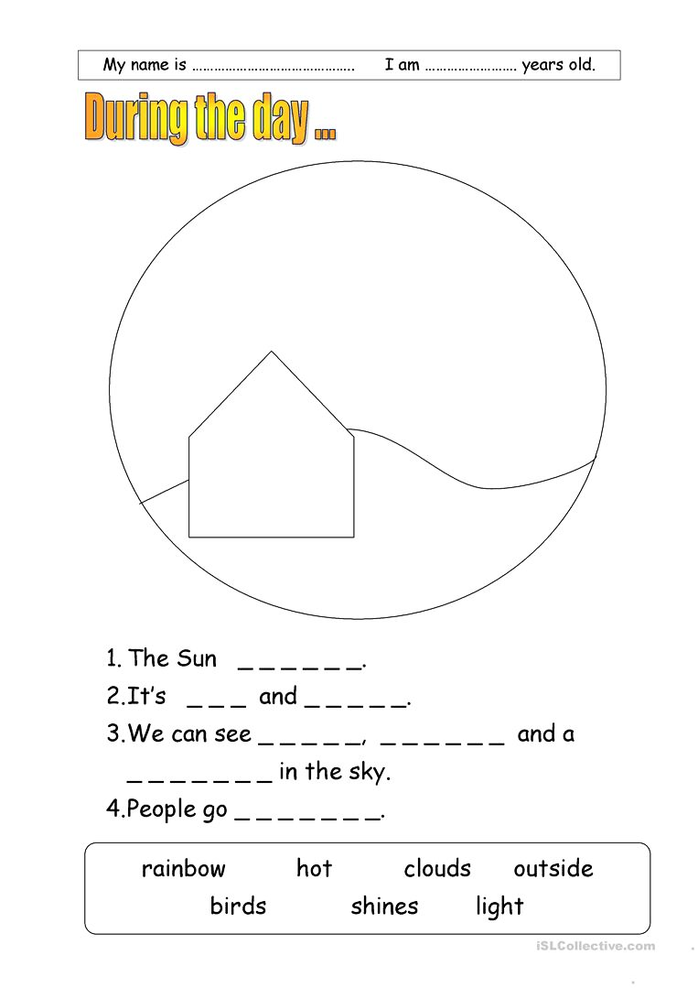







Demonstration School of SuanSunandhaRajabhat University
Science, Teacher : Miss Nungrutai Camhongsa
Name :……………………………..……..………………….Class…..…..…No……….

