Demonstration School of SuanSunandhaRajabhat University
Science, Date : 20/06/2022 , Teacher : Miss Nungrutai Camhongsa
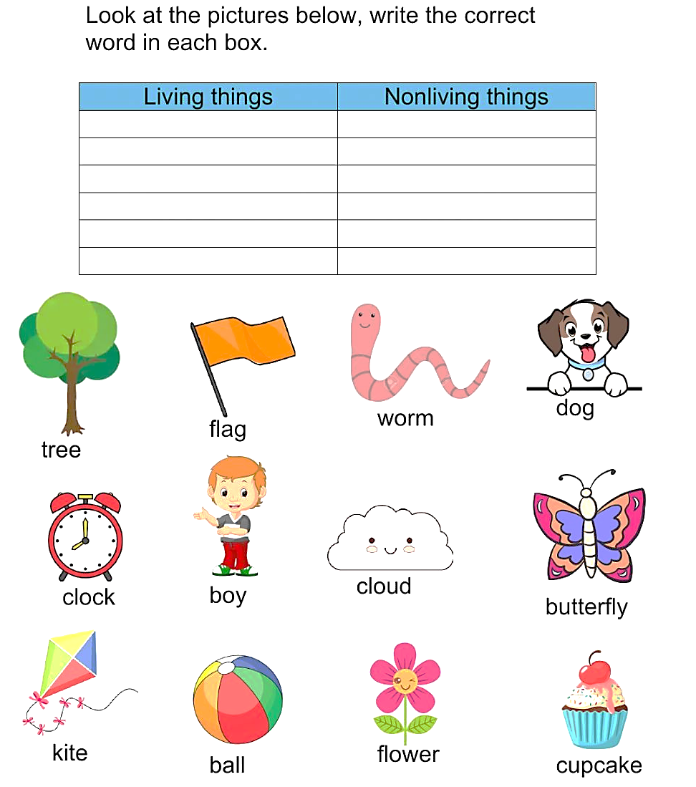
Name :…………………………………………………………………….Class………………No…………

