Demonstration School of SuanSunandhaRajabhat University
Science, Teacher : MissNungrutai Camhongsa
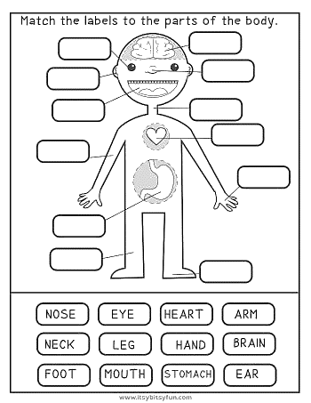
Name..................................................................... :.Class............ No.............

